SUPPLEMENTARY MATERIALS

FIGURES
Supplementary Figure 1. Cumulative incidence of other comorbidities among fatigue cohorts.
- Autoimmune thyroid
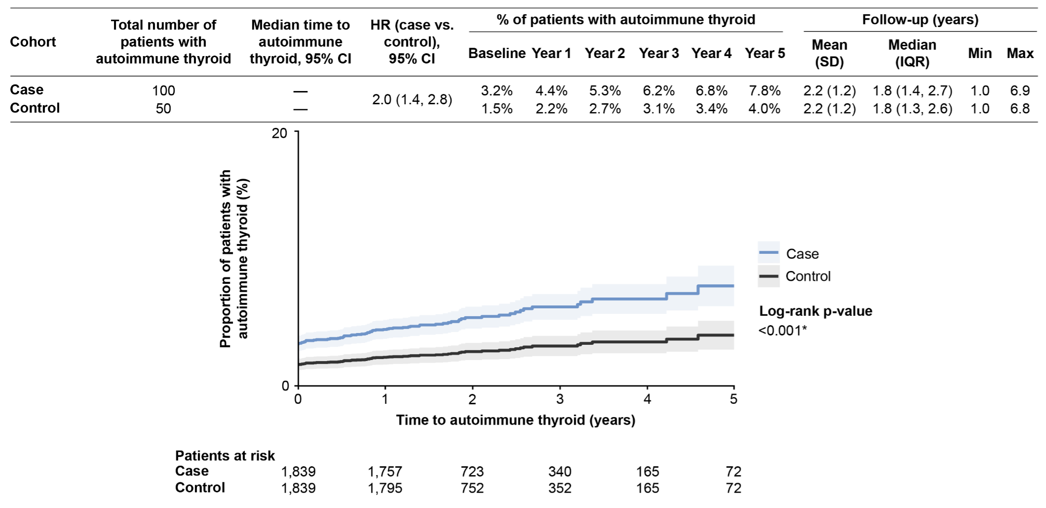
Proportion (shown as a percentage) of patients with autoimmune thyroid over time (blue line represents case cohort and black line is control cohort). Level of significance: log-rank p-value <0.001.
- Sjögren’s disease
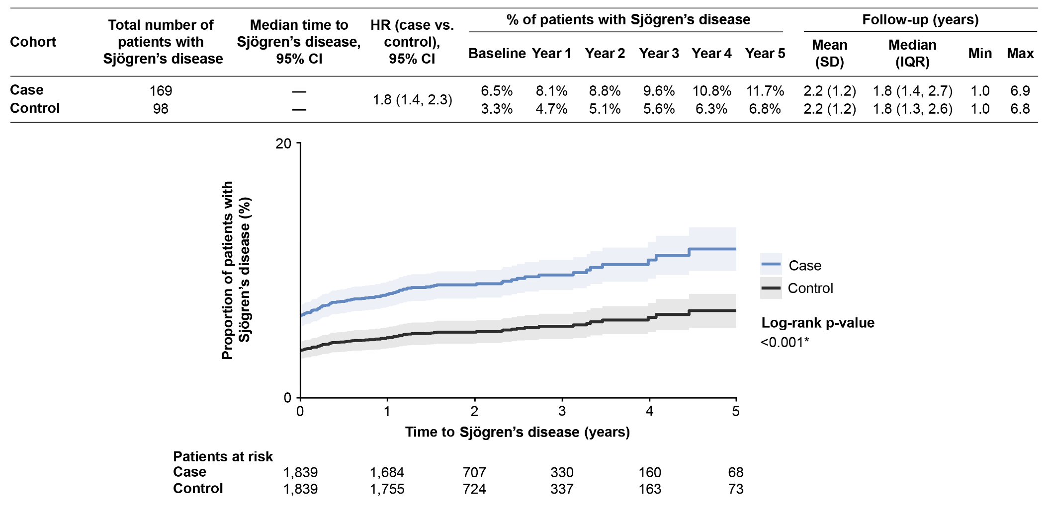
Proportion (shown as a percentage) of patients with Sjögren’s disease over time (blue line represents case cohort and black line is control cohort). Level of significance: log-rank p-value <0.001.
- Raynaud’s syndrome
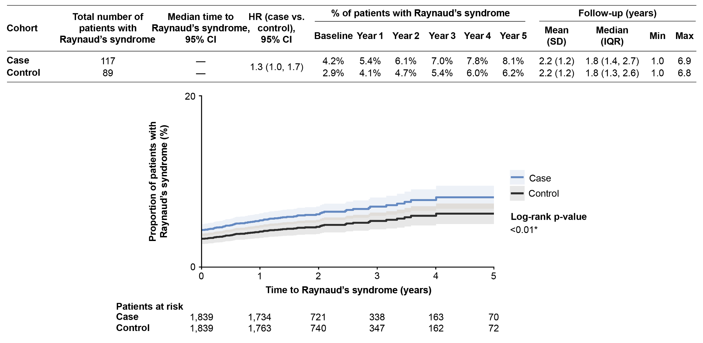
Proportion (shown as a percentage) of patients with Raynaud’s syndrome over time (blue line represents case cohort and black line is control cohort). Level of significance: log-rank p-value <0.01.
- Systemic lupus erythematosus
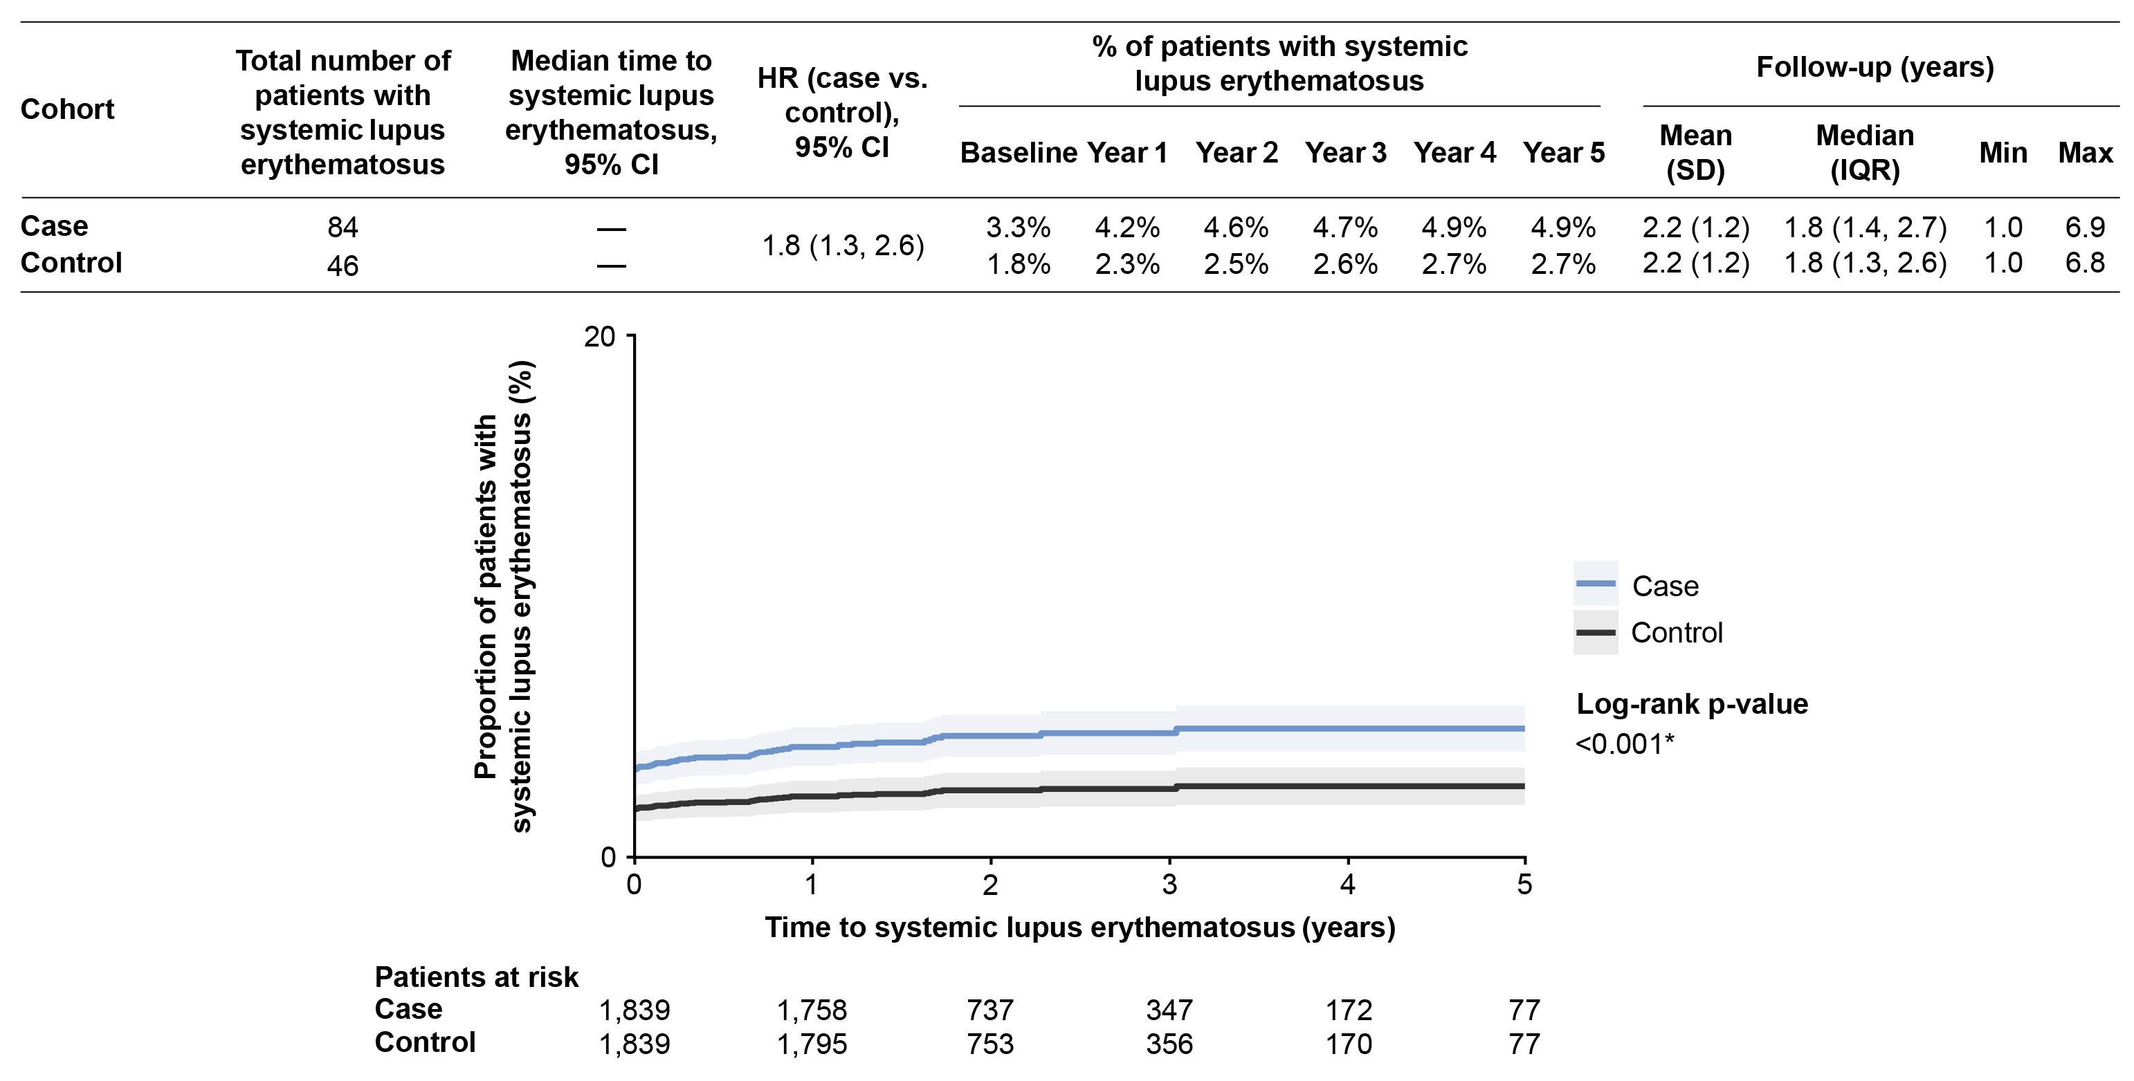
Proportion (shown as a percentage) of patients with systemic lupus erythematosus over time (blue line represents case cohort and black line is control cohort). Level of significance: log-rank p-value <0.001.
- Rheumatoid arthritis
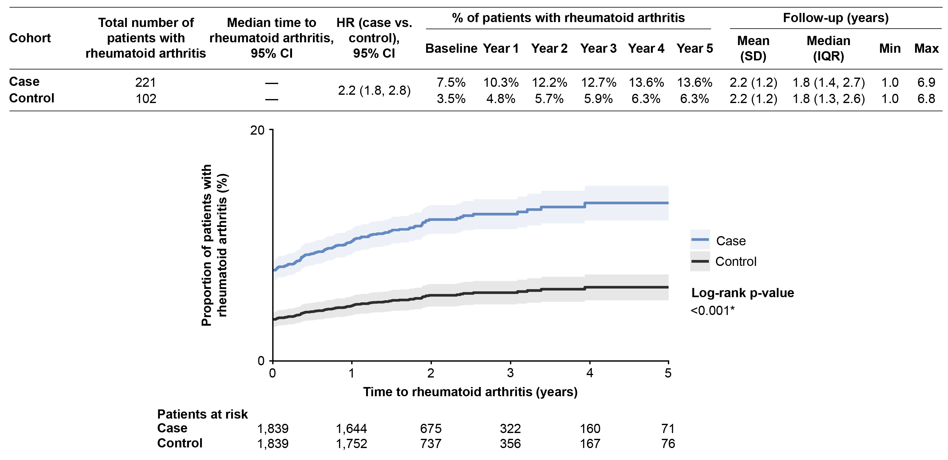
Proportion (shown as a percentage) of patients with rheumatoid arthritis over time (blue line represents case cohort and black line is control cohort). Level of significance: log-rank p-value <0.001.
- Cognitive impairment
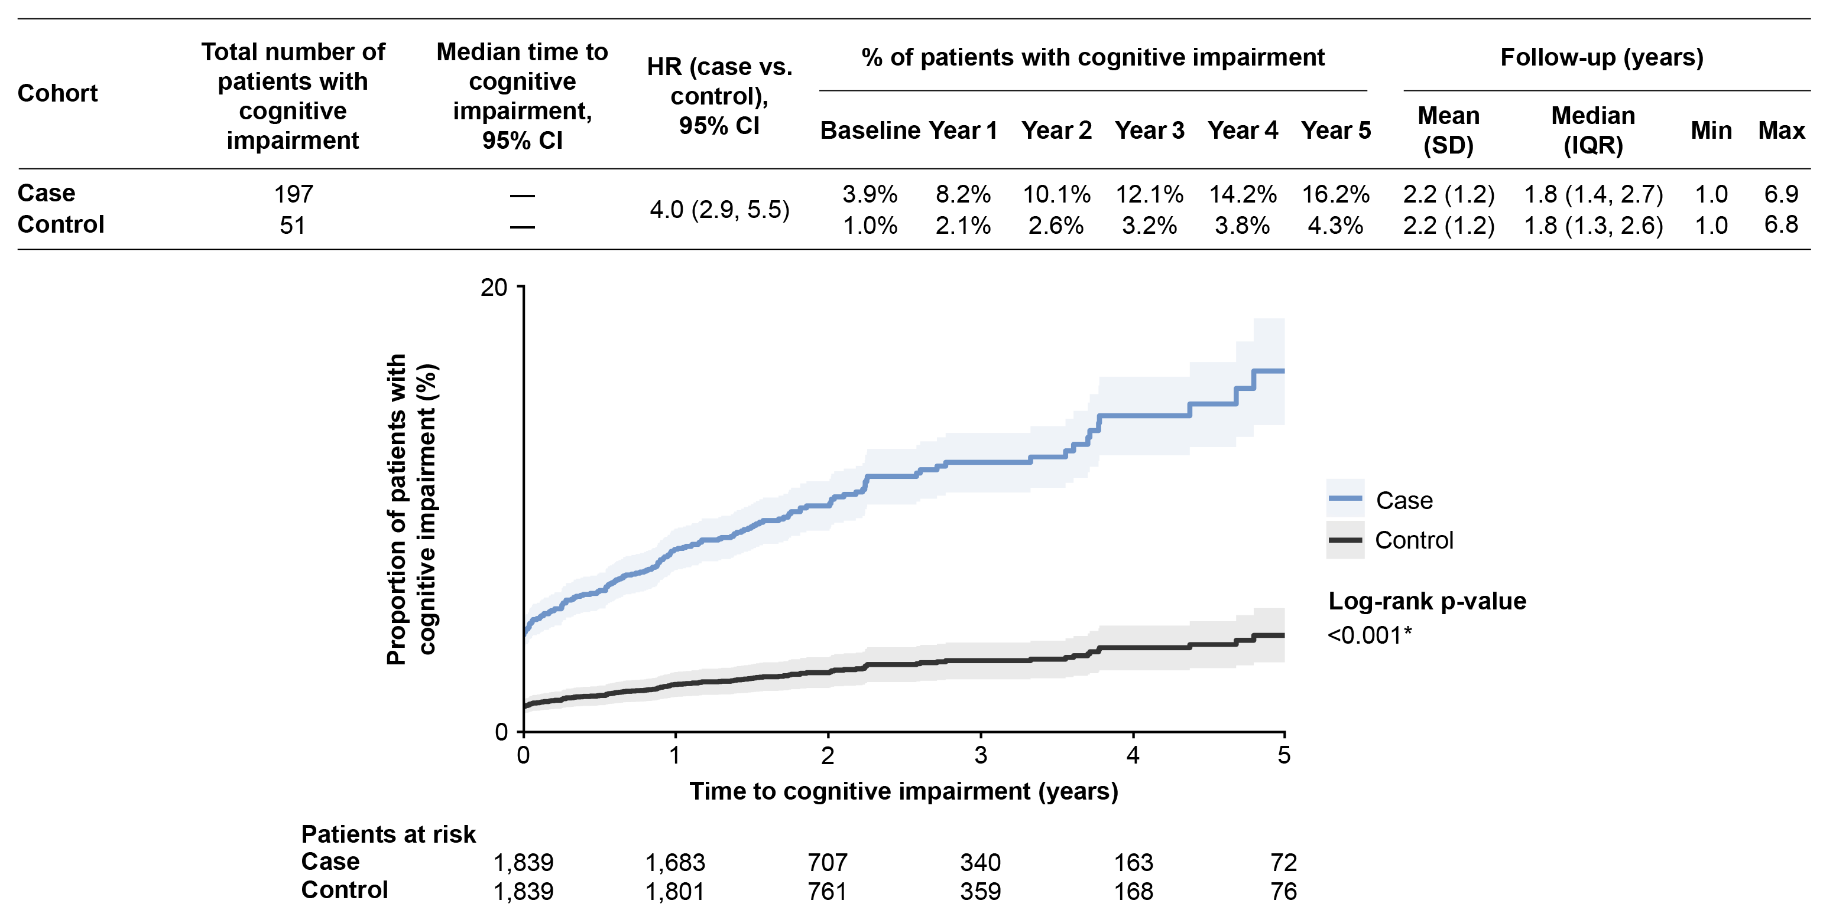
Proportion (shown as a percentage) of patients with cognitive impairment over time (blue line represents case cohort and black line is control cohort). Level of significance: log-rank p-value <0.001.
Abbreviations: CI, Confidence interval; HR, Hazard ratio; IQR, Interquartile range; SD, Standard deviation.
Supplementary Figure 2. Cumulative incidence of other comorbidities among pruritus cohorts.
- Autoimmune thyroid
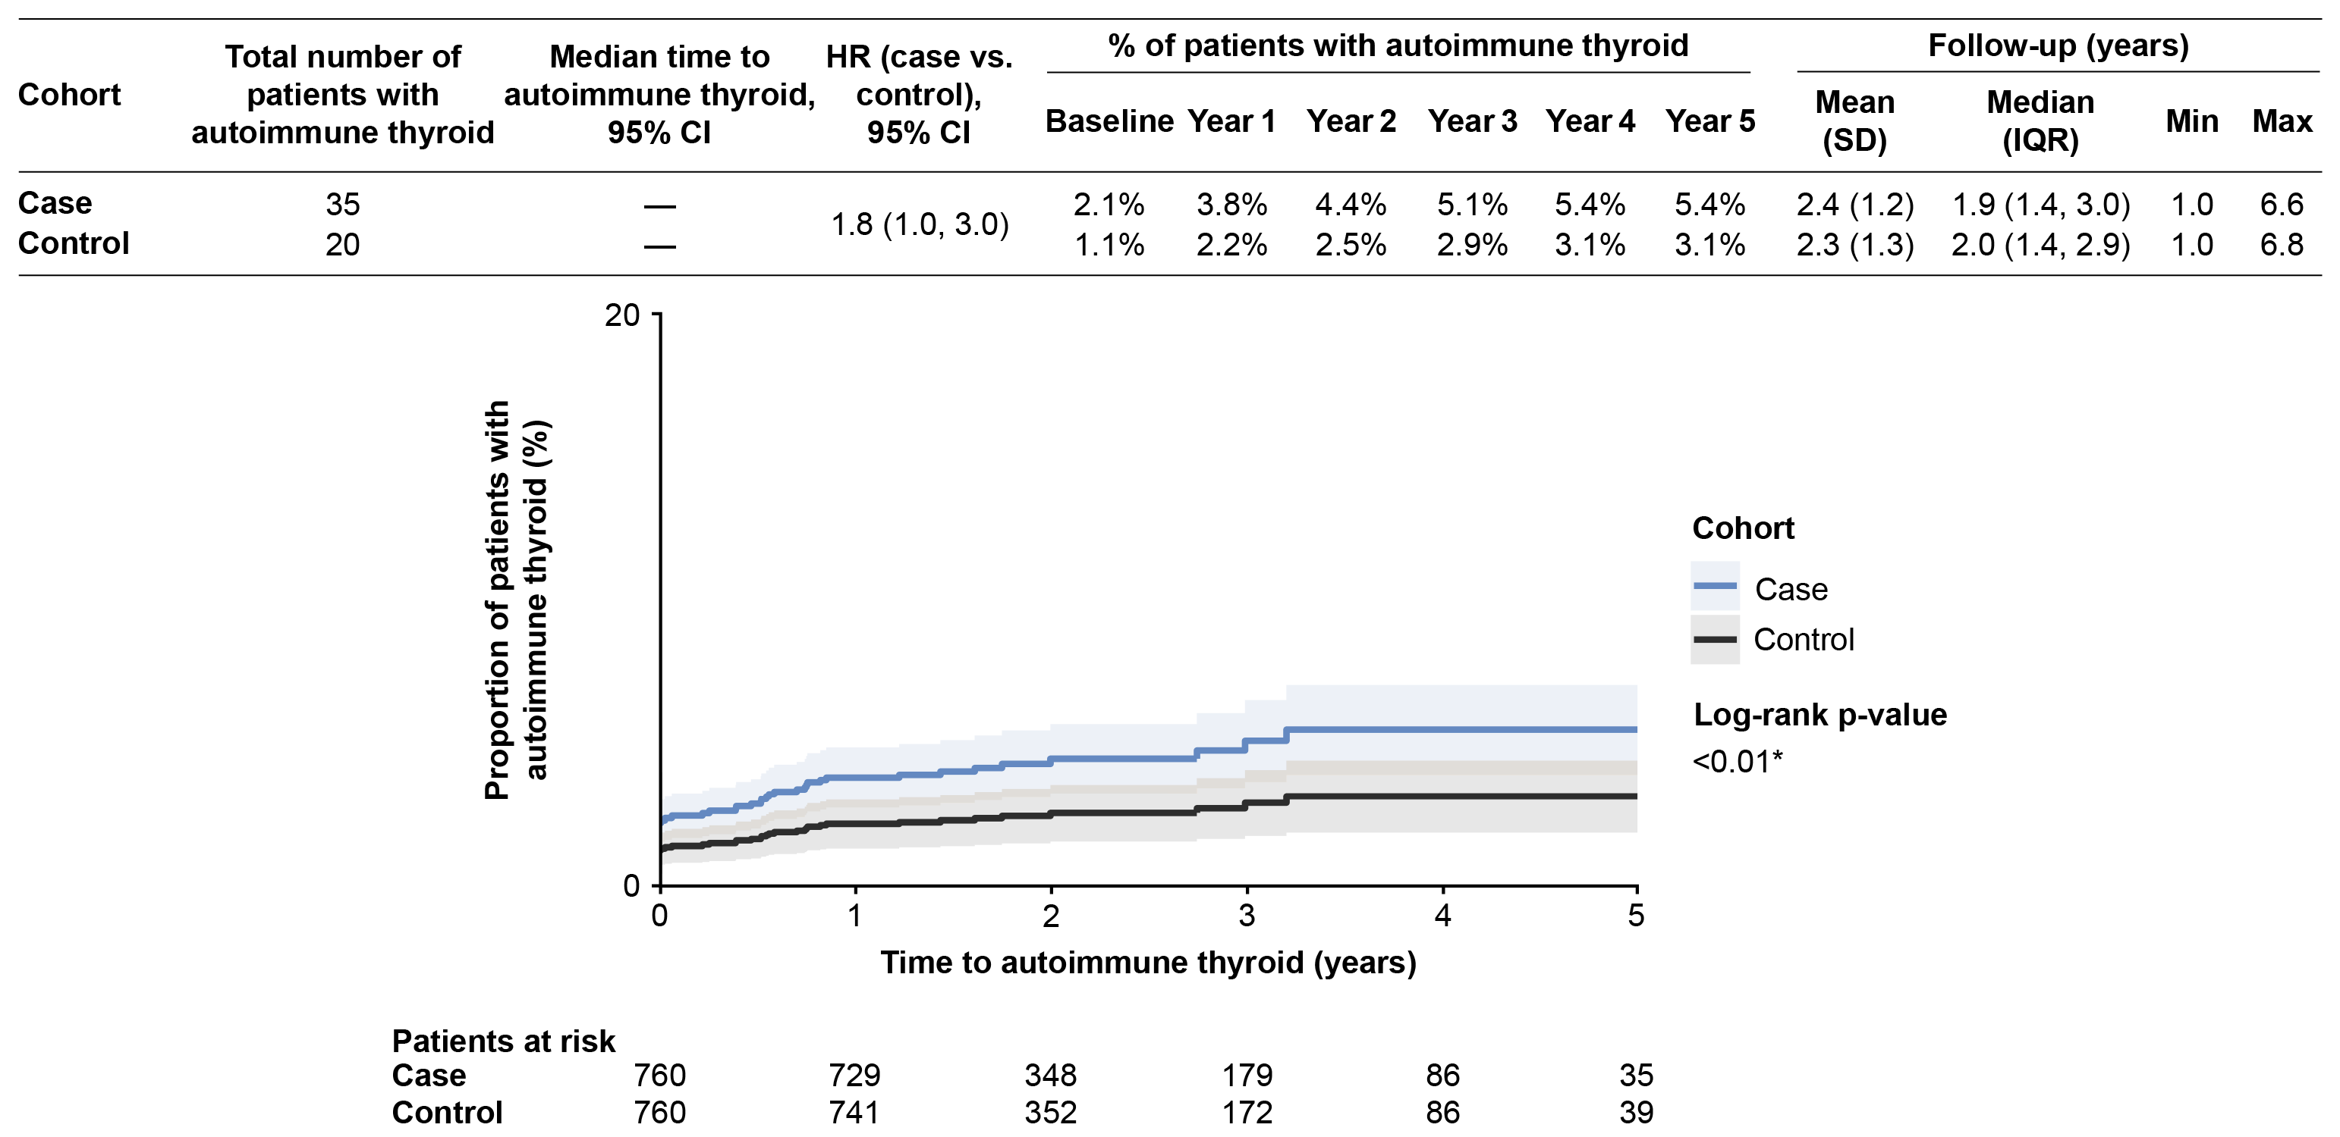
Proportion (shown as a percentage) of patients with autoimmune thyroid over time (blue line represents case cohort and black line is control cohort). Level of significance: log-rank p-value <0.01.
- Sjögren’s disease
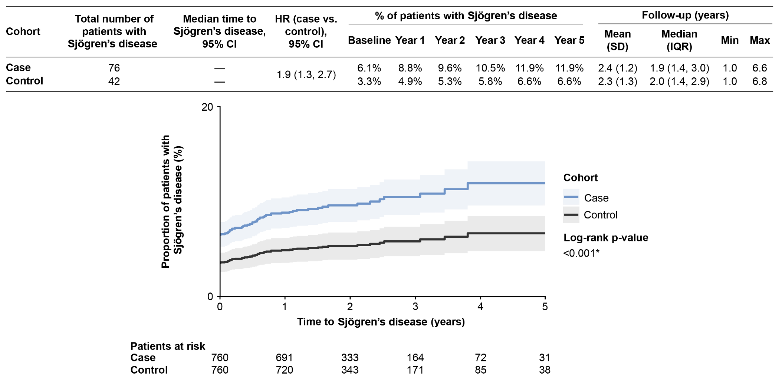
Proportion (shown as a percentage) of patients with Sjögren’s disease over time (blue line represents case cohort and black line is control cohort). Level of significance: log-rank p-value <0.001.
- Raynaud’s syndrome
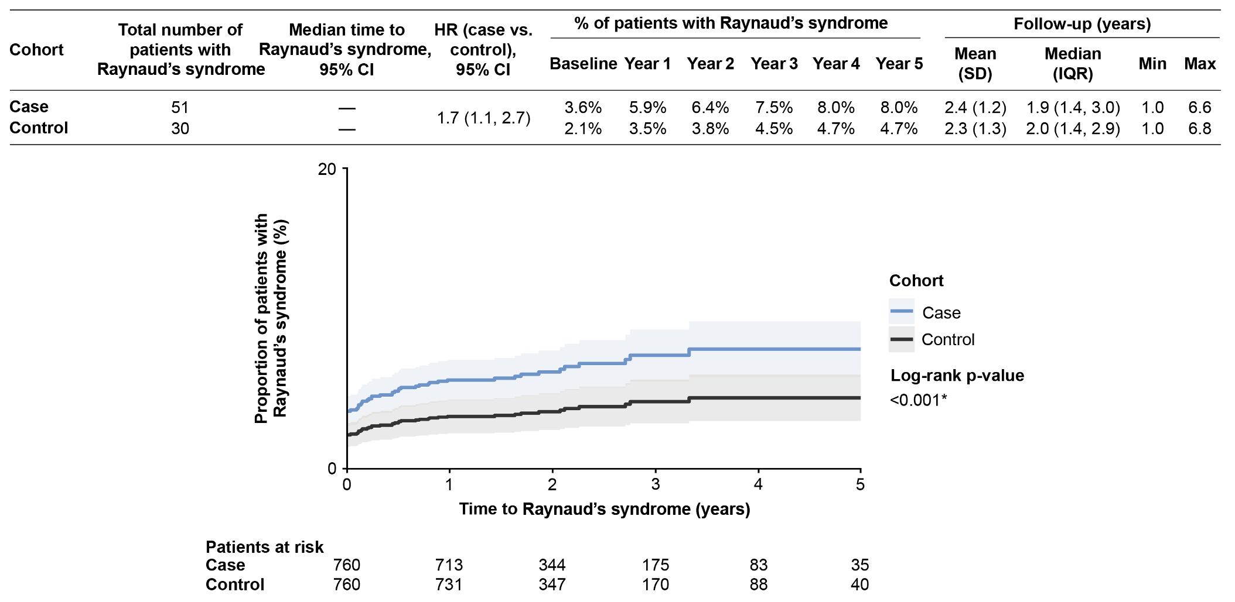
Proportion (shown as a percentage) of patients with Raynaud’s syndrome over time (blue line represents case cohort and black line is control cohort). Level of significance: log-rank p-value <0.001.
- Systemic lupus erythematosus
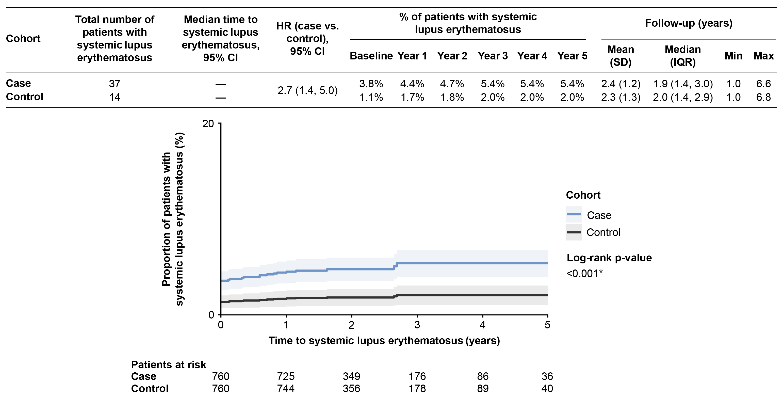
Proportion (shown as a percentage) of patients with systemic lupus erythematosus over time (blue line represents case cohort and black line is control cohort). Level of significance: log-rank p-value <0.001.
- Rheumatoid arthritis
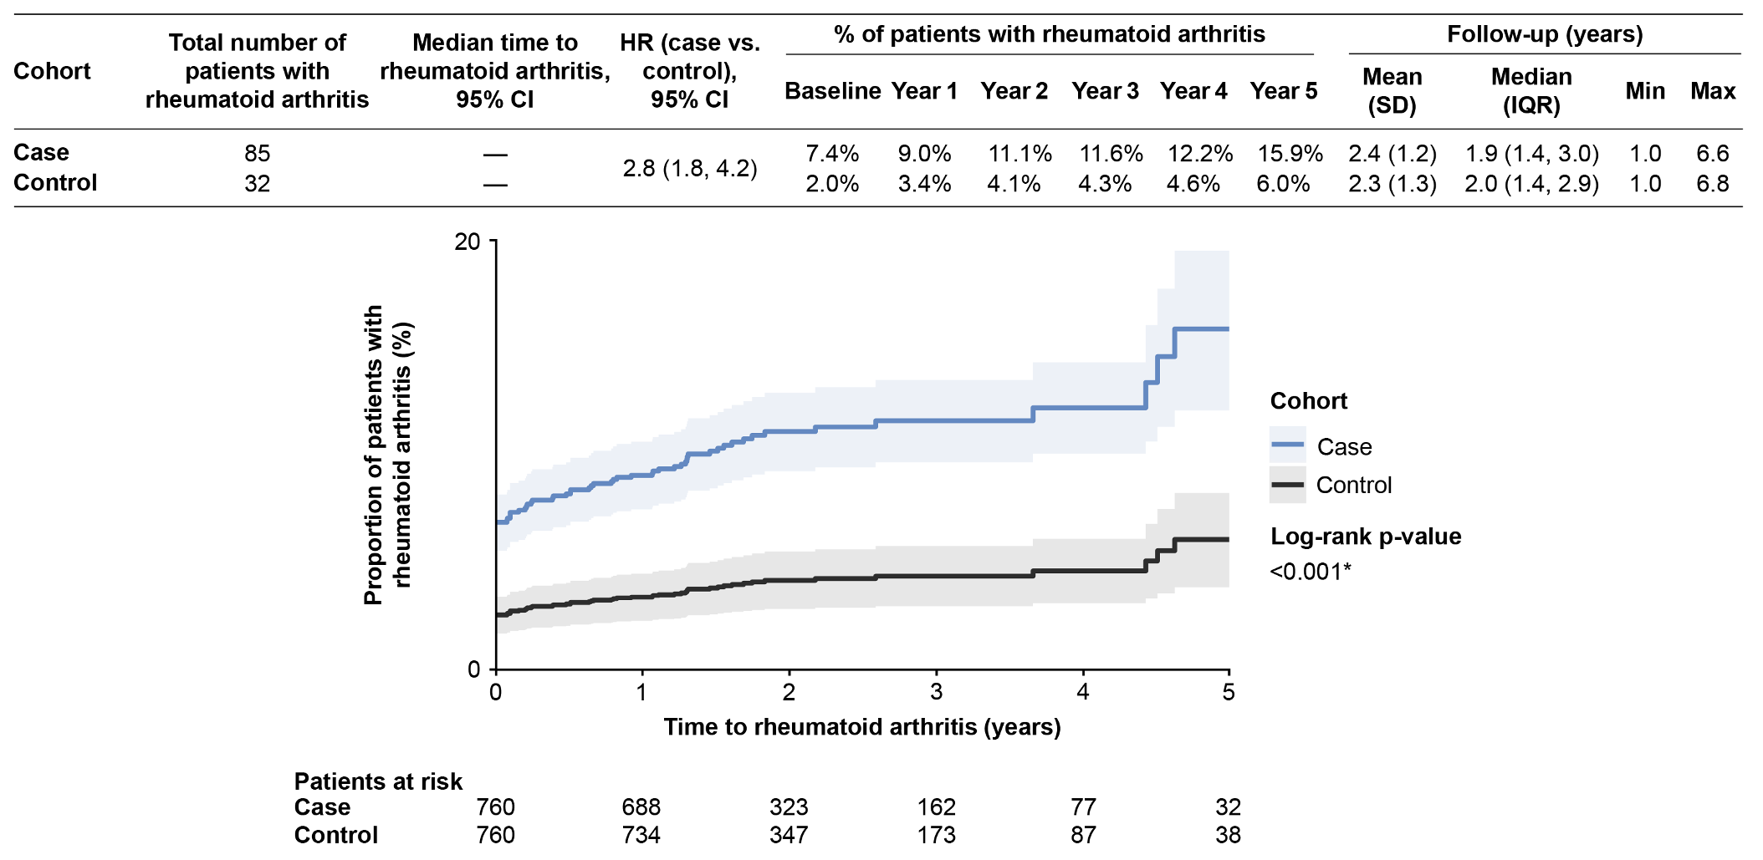
Proportion (shown as a percentage) of patients with rheumatoid arthritis over time (blue line represents case cohort and black line is control cohort). Level of significance: log-rank p-value <0.001.
- Cognitive impairment
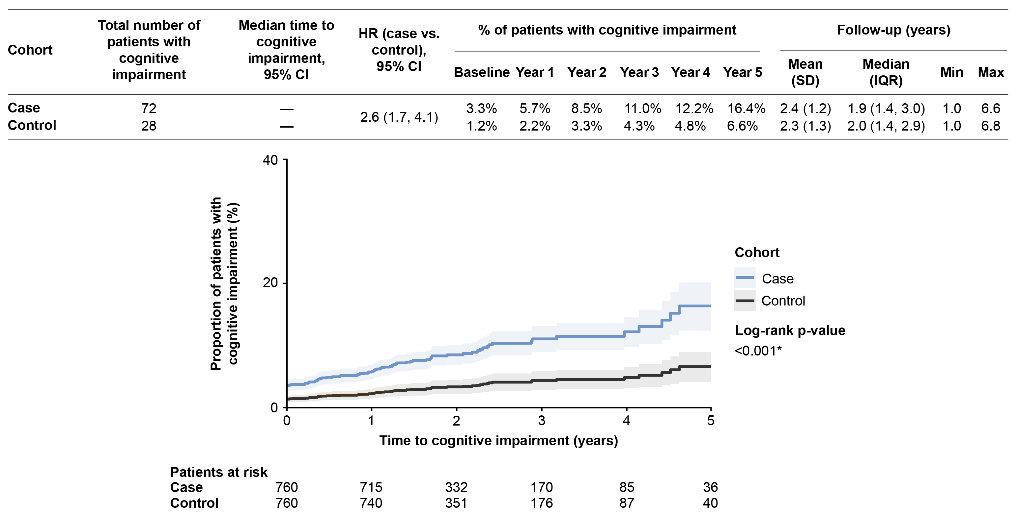
Proportion (shown as a percentage) of patients with cognitive impairment over time (blue line represents case cohort and black line is control cohort). Level of significance: log-rank p-value <0.001.
Abbreviations: CI, Confidence interval ; HR, Hazard ratio; IQR, Interquartile range; SD, Standard deviation.

TABLE
Supplementary Table 1. Baseline characteristics of fatigue or pruritus cohorts before matching.
 | Fatigue cohorts |  |  | Pruritus cohorts
 | Case  (N=2,383) | Control  (N=3,159) | SMD¹ | Case  (N=927) | Control  (N=3,120) | SMD¹
Demographic characteristics
Age at index (years),  mean ± SD | 56.7 ± 11.0 | 57.0 ± 10.1 | 0.021 | 54.8 ± 11.4 | 56.8 ± 10.0 | 0.193
Female, n (%) | 2,053 (86.2%) | 2,687 (85.1%) | 0.031 | 805 (86.8%) | 2,678 (85.8%) | 0.029
Geographic region, n (%) |  |  | 0.200 |  |  | 0.258
South | 1,087 (45.6%) | 1,166 (36.9%) |  | 452 (48.8%) | 1,165 (37.3%)
Midwest | 601 (25.2%) | 882 (27.9%) |  | 211 (22.8%) | 866 (27.8%)
Northeast | 387 (16.2%) | 635 (20.1%) |  | 148 (16.0%) | 628 (20.1%)
West | 305 (12.8%) | 453 (14.3%) |  | 116 (12.5%) | 439 (14.1%)
Unknown | 3 (0.1%) | 23 (0.7%) |  | 0 (0.0%) | 22 (0.7%)
Insurance type |  |  | 0.120 |  |  | 0.073
Commercial | 2,123 (89.1%) | 2,924 (92.6%) |  | 846 (91.3%) | 2,908 (93.2%)
Medicare Advantage | 260 (10.9%) | 235 (7.4%) |  | 81 (8.7%) | 212 (6.8%)
PBC disease characteristics
First observed diagnosis,² n (%) |  |  | 0.208 |  |  | 0.241
2016 | 1,111 (46.6%) | 1,394 (44.1%) |  | 463 (49.9%) | 1,379 (44.2%)
2017 | 410 (17.2%) | 482 (15.3%) |  | 157 (16.9%) | 478 (15.3%)
2018 | 301 (12.6%) | 384 (12.2%) |  | 112 (12.1%) | 380 (12.2%)
2019 | 297 (12.5%) | 345 (10.9%) |  | 102 (11.0%) | 340 (10.9%)
2020 | 199 (8.4%) | 355 (11.2%) |  | 72 (7.8%) | 351 (11.3%)
2021 | 65 (2.7%) | 199 (6.3%) |  | 21 (2.3%) | 192 (6.2%)
PBC duration³ (months), mean ± SD | 20.4 ± 16.8 | 16.2 ± 15.3 | 0.263 | 21.1 ± 16.9 | 16.0 ± 14.8 | 0.323
Comorbidities
CCI,⁴ mean ± SD | 3.2 ± 1.9 | 2.6 ± 1.3 | 0.364 | 3.1 ± 1.7 | 2.6 ± 1.4 | 0.301
Comorbid liver complications, n (%)
Abnormal liver test | 539 (22.6%) | 636 (20.1%) | 0.061 | 231 (24.9%) | 636 (20.4%) | 0.108
Cirrhosis | 685 (28.7%) | 590 (18.7%) | 0.238 | 263 (28.4%) | 585 (18.8%) | 0.228
Autoimmune hepatitis | 297 (12.5%) | 328 (10.4%) | 0.065 | 128 (13.8%) | 335 (10.7%) | 0.094
Portal hypertension | 280 (11.7%) | 187 (5.9%) | 0.207 | 124 (13.4%) | 196 (6.3%) | 0.240
Primary sclerosing cholangitis | 119 (5.0%) | 99 (3.1%) | 0.094 | 65 (7.0%) | 99 (3.2%) | 0.175
Chronic hepatitis NOS | 64 (2.7%) | 96 (3.0%) | 0.021 | 28 (3.0%) | 89 (2.9%) | 0.010
Liver fibrosis | 45 (1.9%) | 55 (1.7%) | 0.011 | 24 (2.6%) | 55 (1.8%) | 0.057
Cholecystitis | 50 (2.1%) | 33 (1.0%) | 0.085 | 12 (1.3%) | 30 (1.0%) | 0.032
Other comorbidities, n (%)
Pruritus | 232 (9.7%) | 0 (0.0%) | 0.464 | 332 (35.8%) | 0 (0.0%) | 1.056
Fatigue | 819 (34.4%) | 0 (0.0%) | 1.023 | 220 (23.7%) | 0 (0.0%) | 0.789
Dyslipidemia | 1,099 (46.1%) | 1,261 (39.9%) | 0.125 | 391 (42.2%) | 1,254 (40.2%) | 0.040
Hypertension | 1,100 (46.2%) | 1,193 (37.8%) | 0.171 | 389 (42.0%) | 1,188 (38.1%) | 0.079
Anxiety | 581 (24.4%) | 449 (14.2%) | 0.260 | 200 (21.6%) | 461 (14.8%) | 0.177
Type 2 diabetes | 476 (20.0%) | 458 (14.5%) | 0.145 | 154 (16.6%) | 444 (14.2%) | 0.066
Depression | 513 (21.5%) | 341 (10.8%) | 0.295 | 175 (18.9%) | 341 (10.9%) | 0.225
Osteoporosis | 294 (12.3%) | 282 (8.9%) | 0.111 | 107 (11.5%) | 279 (8.9%) | 0.086
Urinary tract infection | 371 (15.6%) | 230 (7.3%) | 0.263 | 117 (12.6%) | 228 (7.3%) | 0.178
Gallstone disease (cholelithiasis) | 217 (9.1%) | 239 (7.6%) | 0.056 | 78 (8.4%) | 212 (6.8%) | 0.061
Diarrhea | 317 (13.3%) | 171 (5.4%) | 0.273 | 132 (14.2%) | 152 (4.9%) | 0.323
Sleep-related issues | 252 (10.6%) | 141 (4.5%) | 0.233 | 74 (8.0%) | 130 (4.2%) | 0.160
Inflammatory bowel disease | 191 (8.0%) | 111 (3.5%) | 0.194 | 75 (8.1%) | 123 (3.9%) | 0.175
Rheumatoid arthritis | 181 (7.6%) | 107 (3.4%) | 0.186 | 65 (7.0%) | 104 (3.3%) | 0.167
Ulcerative colitis | 127 (5.3%) | 108 (3.4%) | 0.094 | 65 (7.0%) | 99 (3.2%) | 0.175
Sjögren’s disease | 153 (6.4%) | 103 (3.3%) | 0.148 | 56 (6.0%) | 100 (3.2%) | 0.135
Raynaud’s syndrome | 89 (3.7%) | 88 (2.8%) | 0.053 | 32 (3.5%) | 82 (2.6%) | 0.048
Systemic lupus erythematosus | 83 (3.5%) | 53 (1.7%) | 0.114 | 36 (3.9%) | 49 (1.6%) | 0.142
Crohn's disease | 69 (2.9%) | 50 (1.6%) | 0.089 | 32 (3.5%) | 51 (1.6%) | 0.116
Cognitive impairment | 97 (4.1%) | 38 (1.2%) | 0.180 | 32 (3.5%) | 33 (1.1%) | 0.162
Autoimmune thyroid disease | 73 (3.1%) | 49 (1.6%) | 0.101 | 22 (2.4%) | 42 (1.3%) | 0.076
Abbreviations: CCI, Charlson Comorbidity Index; NOS, Not otherwise specified; PBC, Primary biliary cholangitis; SD, Standard deviation; SMD, Standardized mean difference.
1SMD ≥0.1 was considered as imbalanced between the matched pairs.
²Year of first use of PBC diagnostic code post-2016.
3PBC duration is measured from the first observed PBC diagnosis to the index date.
4CCI was calculated based on Quan et al. 2011.[1]

REFERENCES
1. Quan H, Li B, Couris CM et al. Updating and validating the Charlson Comorbidity Index and score for risk adjustment in hospital discharge abstracts using data from 6 countries. Am J Epidemiol. 173, 676–682 (2011).

